### **Project 14: Bluetooth Test**

In 20th century, technology has changed our life. People can work at home with wireless device like mouse, earphone, printer and speaker, which highly enhances our life standard. Bluetooth can make work at home easily, as well as the entertainment. Users can control wirelessly the audio file from PC or Apple iPod within 30 inches. Bluetooth technology can also be used in adapters, allowing people to share their daily life with friends from internet and social media.

#### **Bluetooth Remote Control**

Bluetooth technology is a wireless standard technology that enables short-distance data exchange between fixed devices, mobile devices, and building personal area networks (using UHF radio waves in the ISM band of 2.4 to 2.485 GHz). This kit is equipped with the HM-10 Bluetooth module, which is a master-slave machine. When use as the Host, it can send commands to the slave actively; when use as the Slave, it can only receive commands from the host. The HM-10 Bluetooth module supports the Bluetooth 4.0 protocol, which not only supports Android mobile, but also supports iOS system. In the experiment, we default use the HM-10 Bluetooth module as a Slave and the cellphone as a Host. We install the Bluetooth APP on the mobile phone, connecting the Bluetooth module; finally use the Bluetooth APP to control the parts of smart home kit. We also provide you with 2 types of mobile APP, for Android and iOS system.

**Parameters of HM-10 Bluetooth Module:**  
[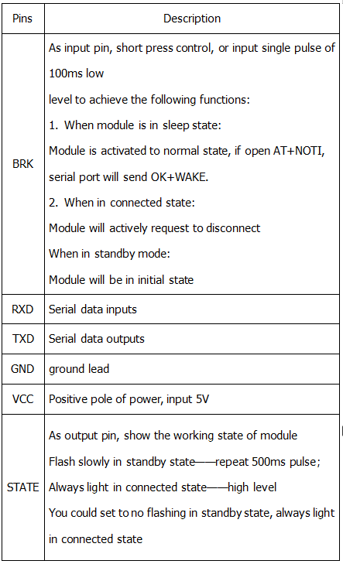](https://wiki.keyestudio.com/File:Ks0085=.png)

* Bluetooth protocol: Bluetooth Specification V4.0 BLE
* No byte limit in serial port Transceiving
* In open environment, realize 100m ultra-distance communication with iphone4s
* USB protocol: USB V2.0
* Working frequency: 2.4GHz ISM band
* Modulation method: GFSK(Gaussian Frequency Shift Keying)
* Transmission power: -23dbm, -6dbm, 0dbm, 6dbm, can be modified by AT command.
* Sensitivity: ≤-84dBm at 0.1% BER
* Transmission rate: Asynchronous: 6K bytes ; Synchronous: 6k Bytes
* Security feature: Authentication and encryption
* Supporting service: Central & Peripheral UUID FFE0, FFE1
* Power consumption: Auto sleep mode, stand by current 400uA~800uA, 8.5mA during transmission.
* Power supply: 5V DC
* Working temperature: –5 to +65 Centigrade

#### **Using Bluetooth APP**

**Description：**

In the previous lesson, we’ve introduced the basic parameter principle of HM-10 Bluetooth module. In this project, let's show you how to use the HM-10 Bluetooth module. In order to efficiently control this kit by HM-10 Bluetooth module, we specially designed an APP, as shown below.

[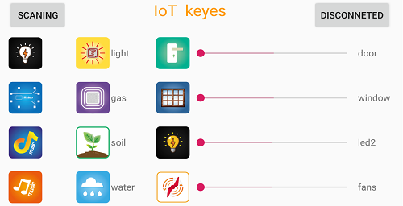](https://wiki.keyestudio.com/File:Ks008552.png)

There are 16 control buttons in the app. When we connect the HM-10 Bluetooth module and app, only press control button of APP, and the Bluetooth of cellphone sends a control character. The Bluetooth module will receive a corresponding control character. When programming, we set the corresponding function of each sensor or module according to the corresponding key control character. Next, let’s test 16 buttons on app.

APP for Android mobile：

Note: You need to enable the location information before connecting to HM-10 Bluetooth module via cellphone, otherwise, Bluetooth may not be connected.

Enter google play，search “keyes IoT”，if you can’t search it on app store, please download app in the following link：  
<https://play.google.com/store/apps/details?id=com.keyestudio.iot_keyes>

After installing and open the app [IMG_258](https://wiki.keyestudio.com/File:Ks008553.png) ，the interface pops up as below:

[](https://wiki.keyestudio.com/File:Ks008552.png)

Upload code and power on, Led of Bluetooth module blinks. Start Bluetooth and open App to click “CONNECT” to connect.

[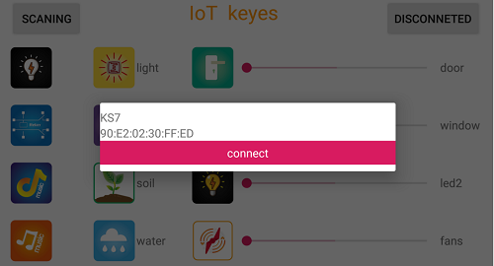](https://wiki.keyestudio.com/File:Ks008554.png)

Click to “Connect”, Bluetooth is connected successfully. As shown below, the LED of Bluetooth module is normally on.

[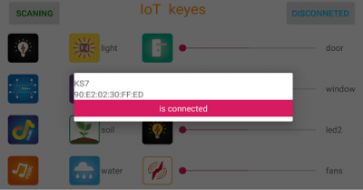](https://wiki.keyestudio.com/File:Ks008555.png)

**For IOS system：**

(1) Open App Store [](https://wiki.keyestudio.com/File:0488-78.png)

(2) Search “IoT keyes”on APP Store，then click “downlaod”.

[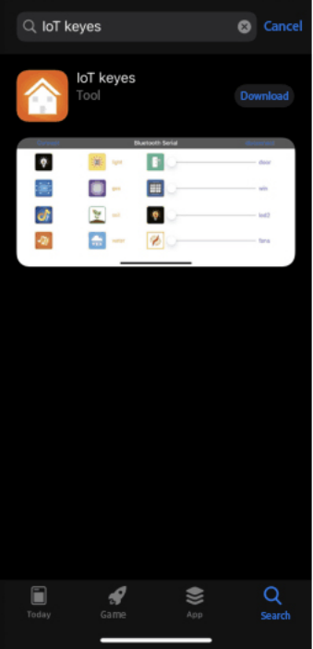](https://wiki.keyestudio.com/File:Ks008557.png)

（3）After installing successfully and open [IMG_264](https://wiki.keyestudio.com/File:Ks008553.png)，the interface is shown below:  
[](https://wiki.keyestudio.com/File:Ks008552.png)

(4)Upload the test code successfully, insert the Bluetooth module and power on. LED of Bluetooth module is flashing. Start Bluetooth on cellphone, then click “connect” on the left to search Bluetooth and pair. After paring successfully, the LED of Bluetooth module is on. Note: Remove the Bluetooth module please, when uploading the test code. Otherwise, the program will fail to upload. Connect the Bluetooth and Bluetooth module to pair after uploading the test code.

4.Connection Diagram

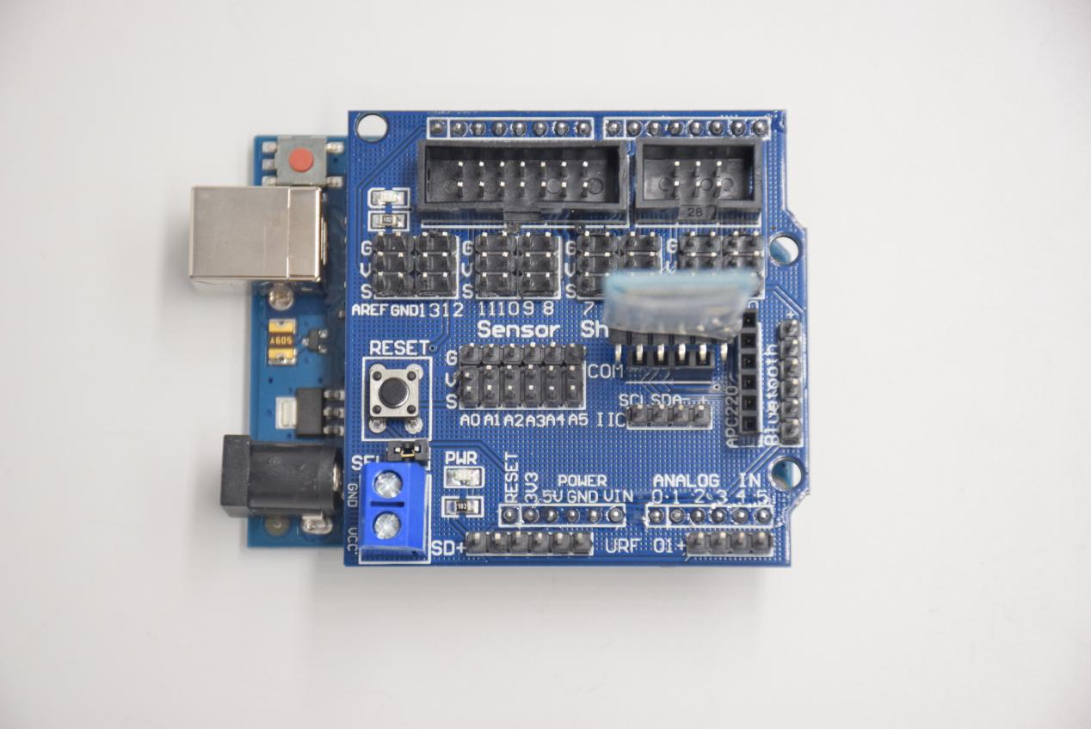

Bluetooth module:

STATE -- No answer

RXD -- TX

TXD -- RX

GND -- -

VCC -- +

EN -- No answer

**Test Code：**

char val;

void setup()

{

Serial.begin(9600);// Set the serial port baud rate to 9600

}

void loop()

{

while (Serial.available()>0)

{

val=Serial.read();// Read the value sent by Bluetooth

Serial.print(val);// The serial port prints the read value

}

}